--Barry Bonds career statistics

SELECT nameFIRST, nameLAST, yearID, teamID, G, AB, R, H, 2B, 3B, HR, RBI, SB, CS, BB, SO, IBB, HBP, SH, SF, GIDP FROM Batting

INNER JOIN people

ON batting.playerID = people.playerID

WHERE nameFIRST = 'Barry'

AND nameLAST = 'Bonds'

ORDER BY yearID ASC;

--Tim Lincecum Career statistics

SELECT nameFIRST, nameLAST, yearID, teamID, W, L, G, GS, CG, SHO, SV, H, ER, HR, BB, SO, BAOpp, ERA FROM pitching

INNER JOIN people

ON pitching.playerID = people.playerID

WHERE nameFIRST = 'Tim'

AND nameLAST = 'Lincecum'

ORDER BY yearID ASC;

--Players with more RBIs than games played in a season

SELECT yearID, nameFIRST, nameLAST, G, RBI, RBI-G AS Differential FROM batting

JOIN people

ON batting.playerID = people.playerID

WHERE RBI > G

AND G >= 100

ORDER BY Differential DESC;

--ERAs of 300 game winners

ALTER TABLE pitching

ADD InningsPitched AS IPOuts/3

SELECT nameFIRST, nameLAST, SUM(W) AS W, CONVERT(DECIMAL(3,2),(9\*(CAST(SUM(ER) AS numeric)/CAST(SUM(InningsPitched) AS numeric)))) AS ERA FROM Pitching

INNER JOIN people

ON pitching.playerID = people.playerID

WHERE InningsPitched >= 1

GROUP BY nameFIRST, nameLAST

HAVING SUM(W) >= 300

ORDER BY ERA ASC;

--Players to both win 20 games and lose 20 games in a season post 1900

SELECT yearID, nameFIRST, nameLAST, W, L FROM Pitching

JOIN people

ON Pitching.playerID = people.playerID

WHERE W >= 20 AND L >= 20 AND yearID >= 1900

ORDER BY yearID DESC;

--Most Homeruns by left-handed hitting shortstops (sort of)

--Due to the imitations of the database this query only accurately works if a player exclusively played shortstop for a full season.

--Would need a game by game/positional breakdown from batting to complete it.

SELECT DISTINCT nameFIRST, nameLAST, bats, POS, SUM(fielding.G) AS G, SUM(batting.HR) AS HR FROM batting

INNER JOIN fielding

ON batting.playerID = fielding.playerID AND batting.yearID = fielding.yearID

INNER JOIN people

ON fielding.playerID = people.playerID

WHERE bats = 'L' AND POS = 'SS'

GROUP BY batting.playerID, nameFIRST, nameLAST, bats, POS

HAVING SUM(fielding.G) >= 1000

ORDER BY HR DESC;

--Players with both 200 Homeruns and 200 Stolen Bases in career

SELECT CONCAT(nameFIRST,' ',nameLAST) AS FullName, SUM(HR) AS HR, SUM(SB) AS SB FROM people

JOIN batting

ON batting.playerID = people.playerID

GROUP BY batting.playerID, people.nameFIRST, people.nameLAST

HAVING SUM(HR) >= 200 AND SUM(SB) >= 200

ORDER BY HR DESC;

--Highest percentage of hits as homeruns in a season minimum 300 at bats

SELECT yearID, nameFIRST, nameLAST, H, HR, CONVERT(DECIMAL(4,2),(CAST(HR AS numeric)/CAST(H AS numeric))\*100) AS pctHR FROM batting

INNER JOIN people

ON batting.playerID = people.playerID

WHERE HR != 0 AND AB >= 300

ORDER BY pctHR DESC;

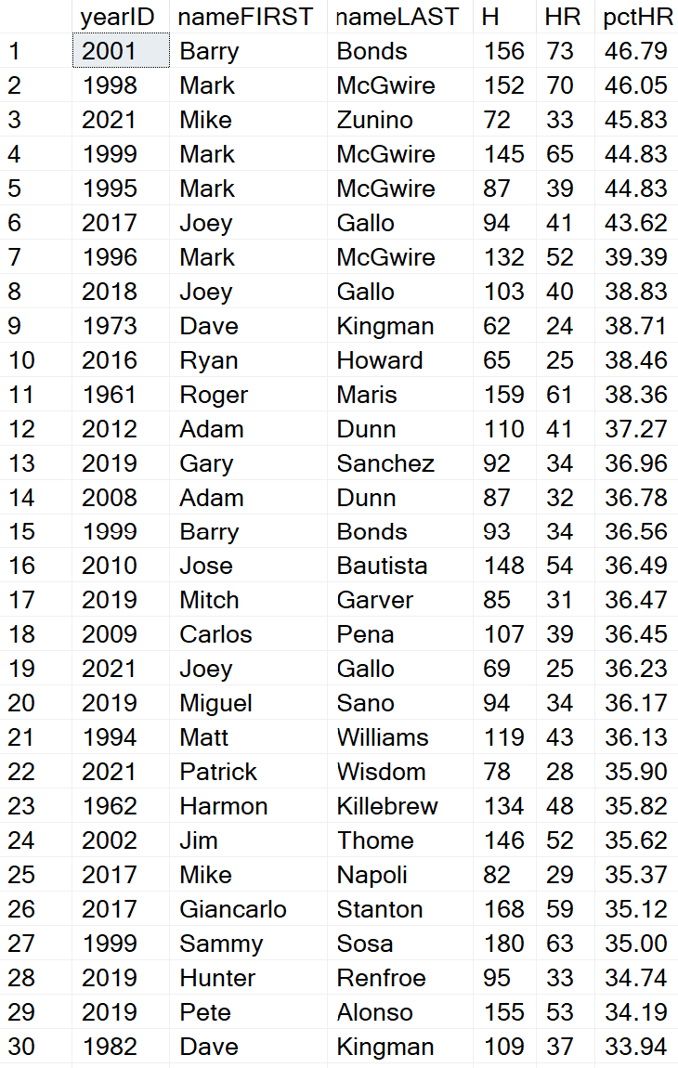

--Players with 100 home runs on three different teams

SELECT teams.nameFIRST, teams.nameLAST, teams.teamHR, teams.teamID FROM

(SELECT people.nameFIRST, people.nameLAST, batting.teamID, SUM(batting.HR) AS teamHR, COUNT(\*) OVER(PARTITION BY batting.playerID) AS numteams FROM batting

INNER JOIN people

ON batting.playerID = people.playerID

GROUP BY batting.playerID, people.nameFIRST, people.nameLAST, batting.teamID

HAVING SUM(HR) >= 100) AS Teams

WHERE numTeams = 3;

--Players hitting homeruns in 20 or more seasons

SELECT nameFIRST, nameLAST, COUNT(DISTINCT batting.yearID) AS numSeasons FROM batting

INNER JOIN people

ON batting.playerID = people.playerID

WHERE HR >= 1

GROUP BY nameFirst, nameLAST, batting.playerID

HAVING COUNT(DISTINCT batting.yearID) >= 20

ORDER BY numSeasons DESC;

--Most HRs by country

SELECT nameFIRST, nameLAST, birthCountry, HR FROM

(SELECT nameFIRST, nameLAST, birthCountry, SUM(HR) AS HR, RANK() OVER(PARTITION BY birthCountry ORDER BY SUM(HR) DESC) AS Rank FROM batting

INNER JOIN people

ON batting.playerID = people.playerID

WHERE birthCountry IS NOT NULL AND nameFIRST IS NOT NULL

GROUP BY batting.playerID, birthCountry, nameFIRST, nameLAST) AS CountryHR

WHERE Rank = 1;

--Oldest Debut

SELECT CONCAT(nameFIRST,' ', nameLAST) AS FullName, YEAR(Debut)-birthYear AS DebutAge FROM people

GROUP BY nameFIRST, nameLAST, birthYear, debut

HAVING YEAR(Debut)-birthYear IS NOT NULL

ORDER BY DebutAge DESC;

--Most HR in a season to not lead MLB

SELECT yearID, CONCAT(nameFIRST, ' ', nameLAST) AS FullName, HR FROM

(SELECT yearID, nameFIRST, nameLAST, HR, RANK() OVER(PARTITION BY yearID ORDER BY HR DESC) AS Rank FROM batting

INNER JOIN people

ON batting.playerID = people.playerID) AS SECHR

WHERE Rank = 2

ORDER BY HR DESC;

--Most Career HR and never lead MLB

SELECT nameFIRST, nameLAST, SUM(HR) AS CareerHR FROM batting

INNER JOIN people

ON batting.playerID = people.playerID

WHERE batting.playerID NOT IN

(SELECT playerID FROM

(SELECT batting.playerID, RANK() OVER(PARTITION BY yearID ORDER BY HR DESC) AS HRRank FROM batting

GROUP BY batting.playerID, yearID, HR) AS CareerNo

WHERE HRRank = 1)

GROUP BY batting.playerID, nameFIRST, nameLAST

ORDER BY CareerHR DESC;

